Theory Question 2

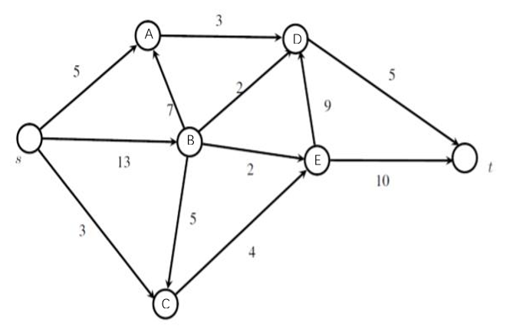

Fig.1 Directed weighted graph for max-flow problem.

1. The directed weighted graph consists of 7 nodes and 10 edges, to find the maximum flow of the directed graph, a linear programme can be formulated.

Knowing that the each weighted edge represent the maximum allowed capacity of flow between each pair of nodes, the following capacity constraints can be formulated:

**0≤Xsa≤5**

**0≤Xsb≤13**

**0≤Xsc≤3**

**0≤Xad≤3**

**0≤Xba≤7**

**0≤Xbc≤5**

**0≤Xbd≤2**

**0≤Xbe≤2**

**0≤Xce≤4**

**0≤Xed≤9**

**0≤Xet≤10**

**0≤Xdt≤5**

-Where for symbol “Xij” means the edge connecting nodes “I” and “j”, so “Xsa” means the edge(capacity) between node S and node A.

Since the graph is a directed graph, for each node, the outgoing edge carries weights of negative values and incident edge carries weight of positive values. Thus, constraints have to be formulated to regulate the directions of flow:

**Node S: -Xsc-Xsa-Xsb=-f**

**Node A:**  **Xsa+Xba-Xad=0**

**Node B:** **Xsb-Xba-Xbc-Xbe-Xbd=0**

**Node C:** **Xsc+Xbc-Xce=0**

**Node D: Xab+Xbd+Xed-Xdt=0**

**Node E: Xbe+Xce-Xed-Xet=0**

**Node T: Xdt+Xet=f**

-Symbol “f” refers to the total amount of flow exiting the source(node S) and entering the sink(node T).

The final formulated linear programme aiming to find the maximum flow of the network is displayed below:

Objective function:

Max:

**|f|**

Subject to:

**-Xsc-Xsa-Xsb=-f**

**Xsa+Xba-Xad=0**

**Xsb-Xba-Xbc-Xbe-Xbd=0**

**Xsc+Xbc-Xce=0**

**Xab+Xbd+Xed-Xdt=0**

**Xbe+Xce-Xed-Xet=0**

**Xdt+Xet=f**

**0≤Xsa≤5**

**0≤Xsb≤13**

**0≤Xsc≤3**

**0≤Xad≤3**

**0≤Xba≤7**

**0≤Xbc≤5**

**0≤Xbd≤2**

**0≤Xbe≤2**

**0≤Xce≤4**

**0≤Xed≤9**

**0≤Xet≤10**

**0≤Xdt≤5**

1. The dual of a maximum flow problem would be a Max-flow min-cut problem, the primal problem is the maximisation of flow, and the dual problem would give the results as the minimum capacity of a cut that separates a network into two disjoint sets, which means the results of the dual problem gives a series of edges with minimum weight compare to other possible cuts.

The dual problem of part a) can be expressed as to minimise $\sum_{(u,v)∈E}{c_{uv}X_{uv}}$, $\sum_{u,v \in E}c_{uv}X_{uv}$ which is the sum of the product of multiplication between the capacity of every edge $***C_{uv}$*** and binary variable of all edges $***X_{uv}$***. $***X_{uv}$*** means the edge connecting node *u* and *v*, $***X_{uv}$***=1 if the cut consists of the edge between node *u*, *v,* and $***X_{uv}***=0 $ otherwise. ***Cuv*** means the maximum capacity of edge between node *u* and *v*.

Knowing the graph is still directed after the cut but nodes would belong to different sets, thus, binary variables are used to find the optimal location of nodes, for example, if node *s* is in the set S, binary variable $***P_s***$would equal to 1, if node *s* is in set T, $***P_s***=0$.

the following constraints for each edge and node will be formulated:

**State binary variable: Ps-Pt≥1**

**Edge SA: Xsa-Ps+Pa≥0**

**Edge SB: Xsb-Ps+Pb≥0**

**Edge SC: Xsc-Ps+Pc≥0**

**Edge AD: Xad-Pa+Pd≥0**

**Edge BA: Xba-Pb+Pa≥0**

**Edge BC: Xbc-Pb+Pc≥0**

**Edge AD: Xbd-Pb+Pd≥0**

**Edge BE: Xbe-Pb+Pe≥0**

**Edge CE: Xce-Pc+Pe≥0**

**Edge DE: Xdt-Pd+Pt≥0**

**Edge ED: Xed-Pe+Pd≥0**

**Edge ET: Xet-Pe+Pt≥0**

The final formulated dual linear programme is displayed below.

Minimise:

**5Xsa+13Xsb+3Xsc+3Xad+7Xba+5Xbc+2Xbd+2Xbe+4Xce+5Xdt+9Xed+10Xet**

Subject to:

**Xsa-Ps+Pa≥0**

**Xsb-Ps+Pb≥0**

**Xsc-Ps+Pc≥0**

**Xad-Pa+Pd≥0**

**Xba-Pb+Pa≥0**

**Xbc-Pb+Pc≥0**

**Xbd-Pb+Pd≥0**

**Xbe-Pb+Pe≥0**

**Xce-Pc+Pe≥0**

**Xdt-Pd+Pt≥0**

**Xed-Pe+Pd≥0**

**Xet-Pe+Pt≥0**

**Ps-Pt≥1**

1. Excel is used as a linear programing solver and the above objective function along with all the constraints have been solved:

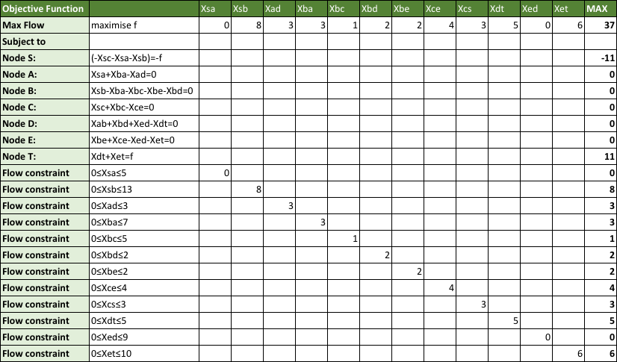

Fig.2 Linear optimization of part a)

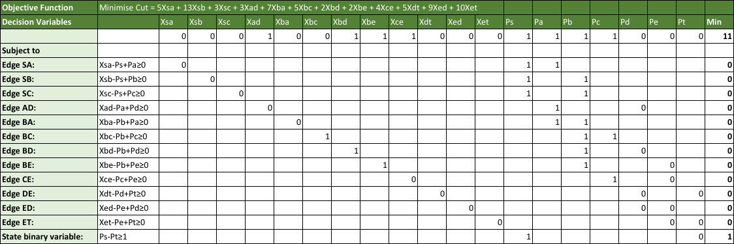

Fig.3 Linear optimization of part b)

The output of the maximized flow is$ |f|=11$.

The minimised cut have a capacity of 11, which equals to the maximum flow, the cut disjoints the graph into two separate sets of nodes: set S and set T (where node s is in set S and node t is in set T), and the linear model of dual problem suggests the set S consists node $*s, a, b*,$ and $*c$*.

1. As mentioned in part b) and part c), by solving the dual of maximum-flow linear programme, the minimum capacity of cut can be obtained.

Knowing a cut s-t separates graph into disjoint sets S and T with node *s* in S and node *t* in T, and nodes in S and nodes in T do not include each other.

The capacity of the cut,$Cap(S,T)$ means the sum of the capacities from $S$ to $T$, and the minimised capacity of the cut can be obtained from the optimal dual value, and Cap(S,T)=11, which equals to the maximum flow in part a) of the question. By setting edges and nodes as binary variables, the results of linear model implies that the minimised capacity of the cut consists of edges $AD, BD, BE,$ and $CE$ (as illustrated in dotted line in the following pitcure, set S consists of nodes $*s*, *a*, *b$*, and *$c$*.

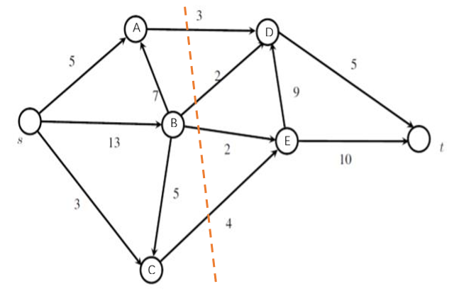

Fig.4 Graph showing the min-cut.